*Horse-drawn Carriage Rides*
* Santa & Mrs. Claus*
*SCOW Teen Carolers*
*Kids’ Scavenger Hunt & Activities*
*Santa’s Enchanted Mailbox*
*Refreshments and FUN!*
Last carriage ride begins at 3:30
Snow/Rain Date TBD

Info: Mary Mushinsky 203-269-8378 or Cathy Granucci 203-314-5665

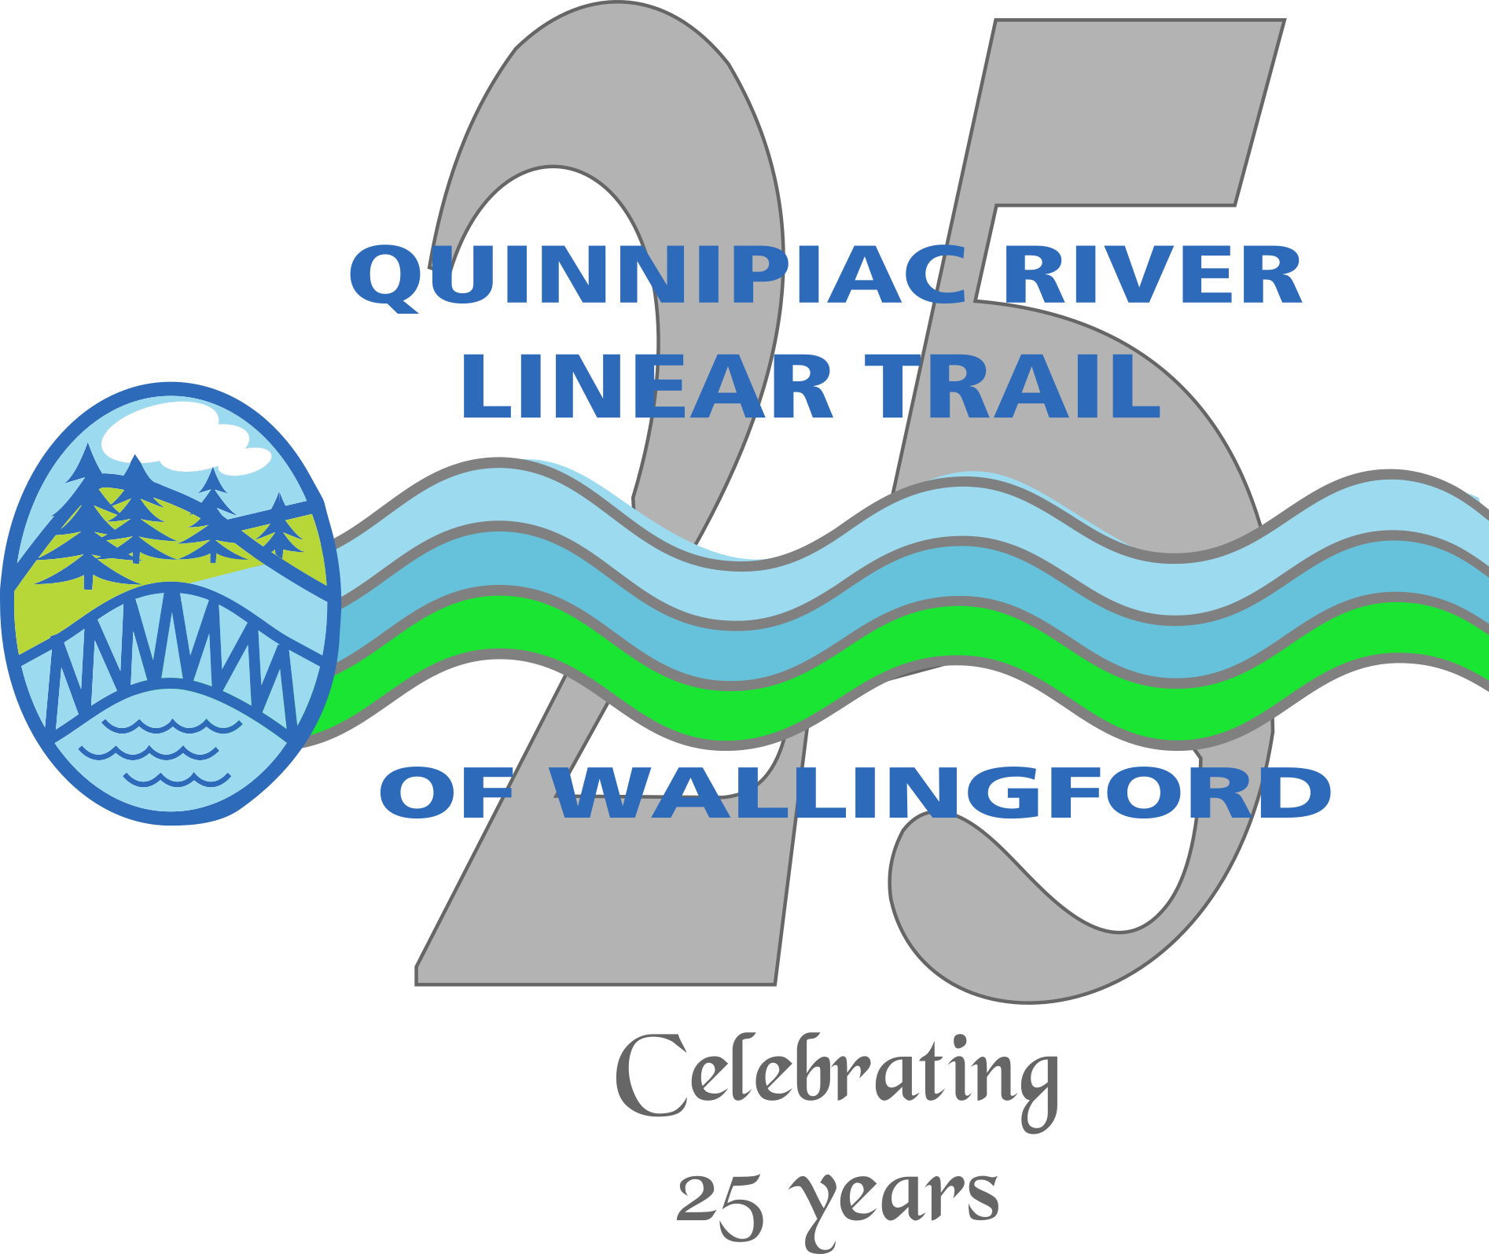

Holiday Celebration

On the Trail
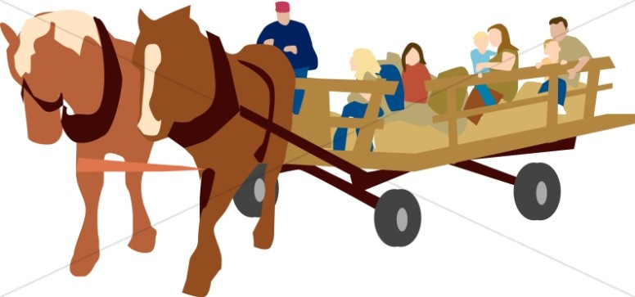
Sunday, November 30, 2025
1:00 p.m. to 3:30 p.m.

Community Lake Park
190 Hall Ave.
Wallingford, CT









