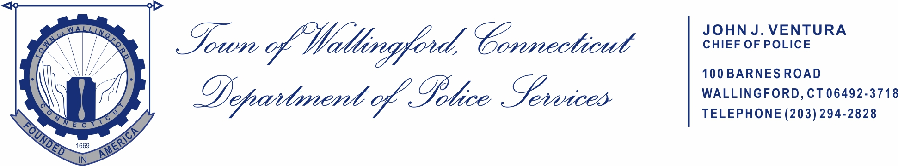

FOR IMMEDIATE RELEASE
Captain Michael Colavolpe
Wallingford Police Department
(203)294-2828

Wednesday, August 19, 2026

No. Main Street/Simpson Court Block Party
Wallingford Center Inc. (WCI), in partnership with the Town of Wallingford, will be hosting a community Block Party on Friday, August 21, 2026, from 6:00 PM to 8:00 PM. The festivities will take place on the public streets of North Main Street and Simpson Court.
For more details, visit the WCI website at www.wallingfordcenterinc.com and look under the “Signature Events” section. If you have any questions, please contact WCI at 203-284-1807.
Road Closures and Parking Restrictions
In accordance with Chapter 216 of the Wallingford Town Code, the following road closures and parking restrictions will be in effect on Friday, August 21, 2026 to support the Block Party:
- North Main Street, between Center Street and Church Street, will be closed to all motor vehicle traffic starting at 5:00 PM. Parking on North Main Street will be prohibited beginning at 4:30 PM.
- Simpson Court will be closed to all motor vehicle traffic starting at 4:30 PM, and parking will be prohibited beginning at 4:00 PM.
Both streets will reopen following the conclusion of the event, which is expected to be around 9:00 PM.
Parking restrictions will be clearly posted in advance. Please note: Vehicles parked in violation of these restrictions will be subject to ticketing and towing by the Wallingford Police Department.
We appreciate your cooperation and look forward to a safe and enjoyable community event!

